|  |
| --- |
|  |
| 20-PBD-002 Shraddha P Jain |
| 3803 – Tableau ESE Assignment |
|  |
|  |
|  |

|  |
| --- |
|  |

Design a Dashboard and Story point for the following sheets. By taking suitable data store. Also, produce the results with the necessary interpretation.

1. Interactive Filter action on summary levels of sum and profit on dual axis.

* Create two new worksheets ‘Sales1’ and ‘Sales2’.
* In ‘Sales1’ sheet, take ‘category’ in row as well as ‘sales’ and ‘profit’in column.
* Right clicking on ‘profit’ and again select dual axis.
* click on sales, and select measure average.
* In marks card, drag and drop ‘measure names’ on colour.
* In ‘Sales2’, drag and drop ‘category’ and ‘sub category’ on column and ‘profit’ and ‘sales’ on row.
* right click on sales and select measure average
* Drag and drop ‘measure names’ on Colour in Marks Card.
* On title bar, go to worksheet- Actions.
* Click on Add Actions-Highlight.
* In Source Sheets, select “sales1” and in Target Sheets select “sales2”.
* See that run action on is Select, and click on ok.
* Now from source sheet, select any desired category & profit or sales, and you will get regarding information in destination.
* After click on desired sales or profit of a category, source and destination will be like,
* It means when you click on Profit of Furniture, in destination it will show you information of profit accordingly.
* 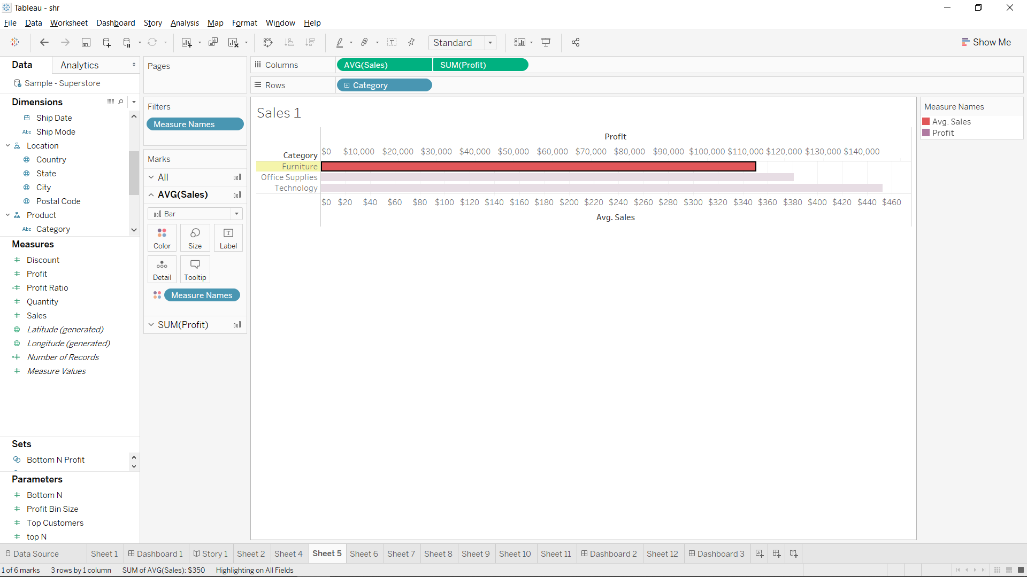
* 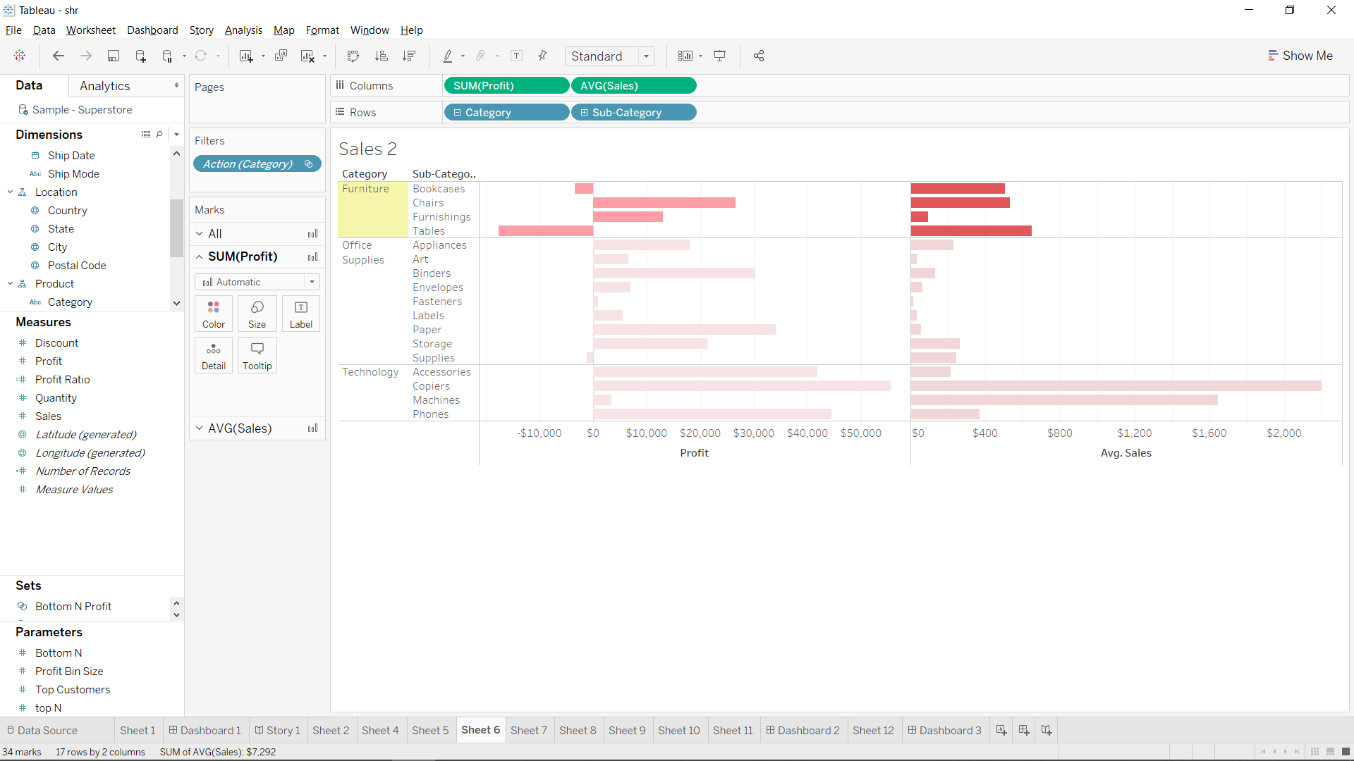
* **Interpretation:** Using Filter Actions on Summary levels, we can easily get the required information by just a single click, and we can use it to highlight what we want.

1. Action filters on country’s sales with the hover option

* Create two new worksheets and rename them as ‘source’ and ‘destination’ respectively.
* In source, drag and drop ‘longitude’ and ‘latitude’ on column and row respectively.
* Drag and drop ‘country’ on colour in marks card.
* In destination, drag and drop ‘category’ and ‘country’ on column section and ‘sales’ on row section.
* Drag and drop ‘category’ on colour and ‘sales’ on labels in marks card.
* From title bar go to Worksheet→Actions→Add Actions→Filter.
* In source sheets select ‘source’ and ‘destination’ in target sheets.
* Click on hover action from Run action on and click on ok.
* From source sheet click on desired country of which you want to observe the sales.
* After hovering on desired country from source, the destination will show the sales of that particular country.
* 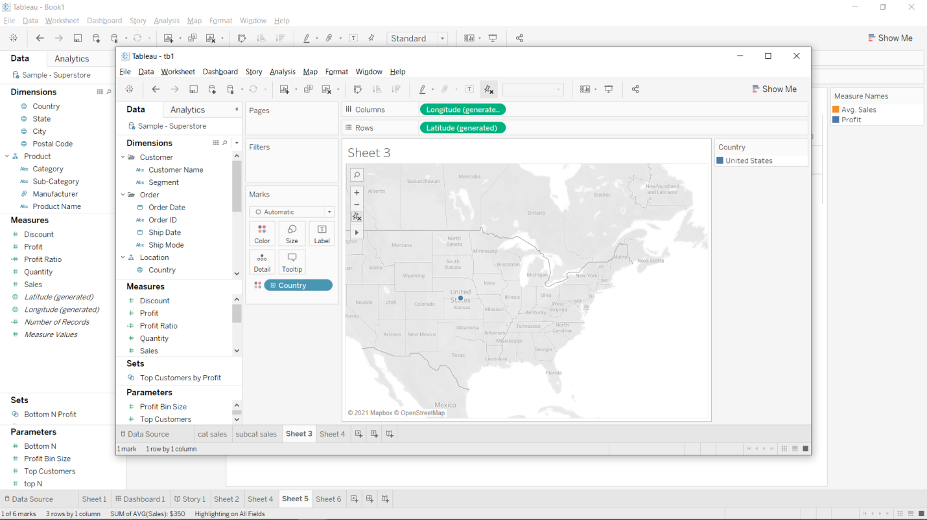
* 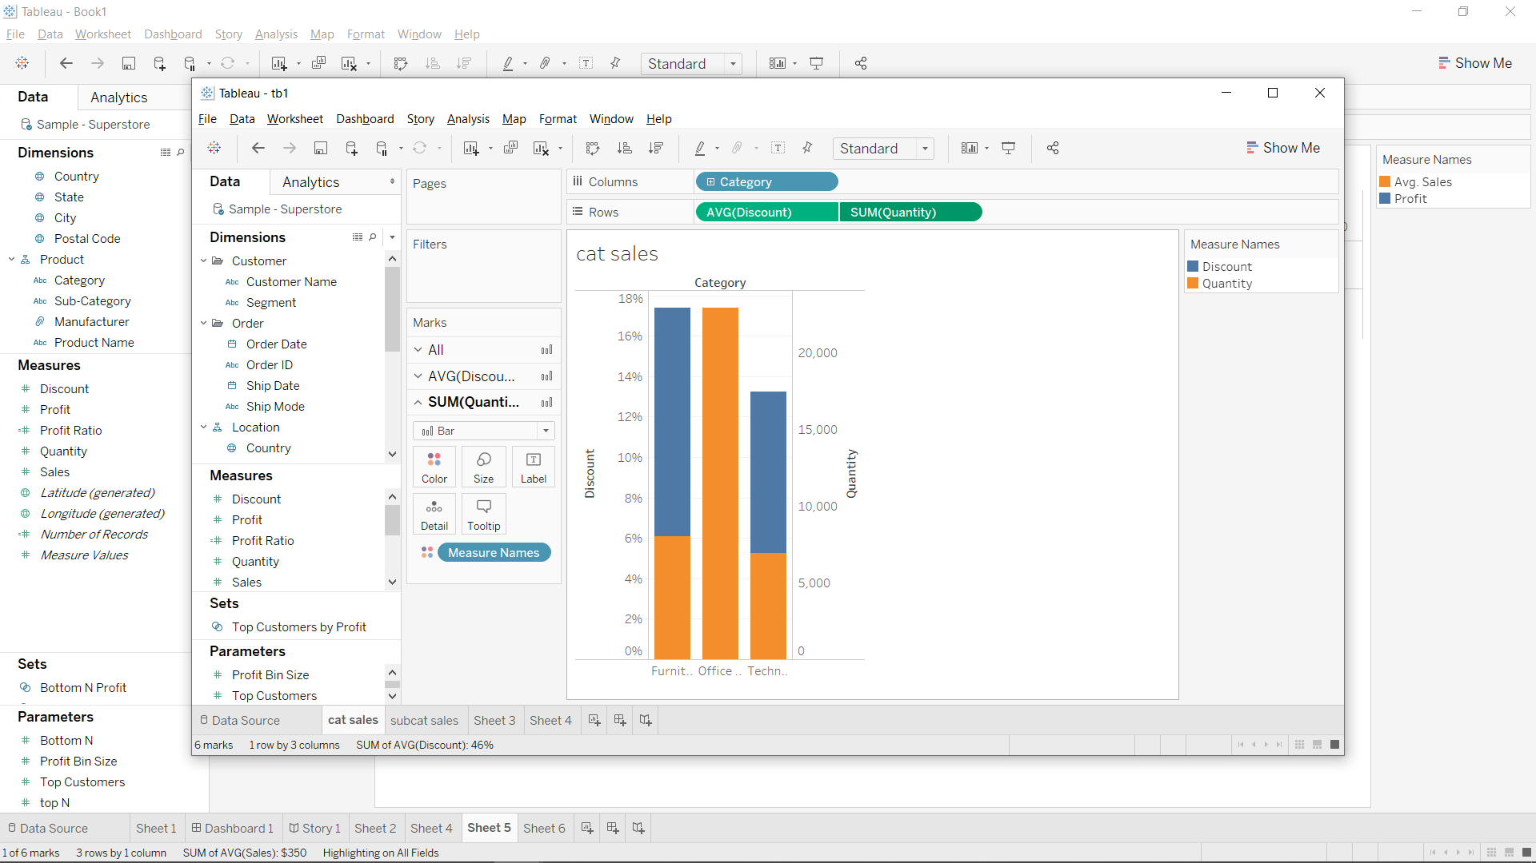

1. Bar and stacked representation with parameter usage for Top 3 Sales& Bottom 4 profit along with the index.

* Create a new worksheet and rename it as Top and Bottom N.
* Drag and drop ‘sales’ and ‘subcategory’ on column and row respectively.
* Drag and drop ‘sales’ on colour and ‘sales’ on labels on marks card.
* Select any dimension and right click on it and go to create-parameter.
* Rename the parameter name by ‘Top N’, set datatype as integer, current value as 5, value when workbook opens as current value, display format as automatic and allowable values as all.
* Click on ok and similarly create another parameter with name ‘Bottom N’.
* Right click on ‘subcategory’ from dimension and select create-set.
* Name the set as ‘top N customers’ and from by field option select ‘top’ and set the value as 5.
* Similarly, create another set as ‘Bottom N Customers’ and from by field option select ‘bottom’ and set the value as 5.
* Now select both these sets and on right clicking them you will find an option to Create Combined Set.
* Name it as **‘**Top N and Bottom N’ and drag and drop it on filters card.
* It will generate the Top 5 and Bottom 5 customers as below.
* Right click on ‘Top N’ parameter and select show parameter, it will generate a legend to control the number of top categories in output.

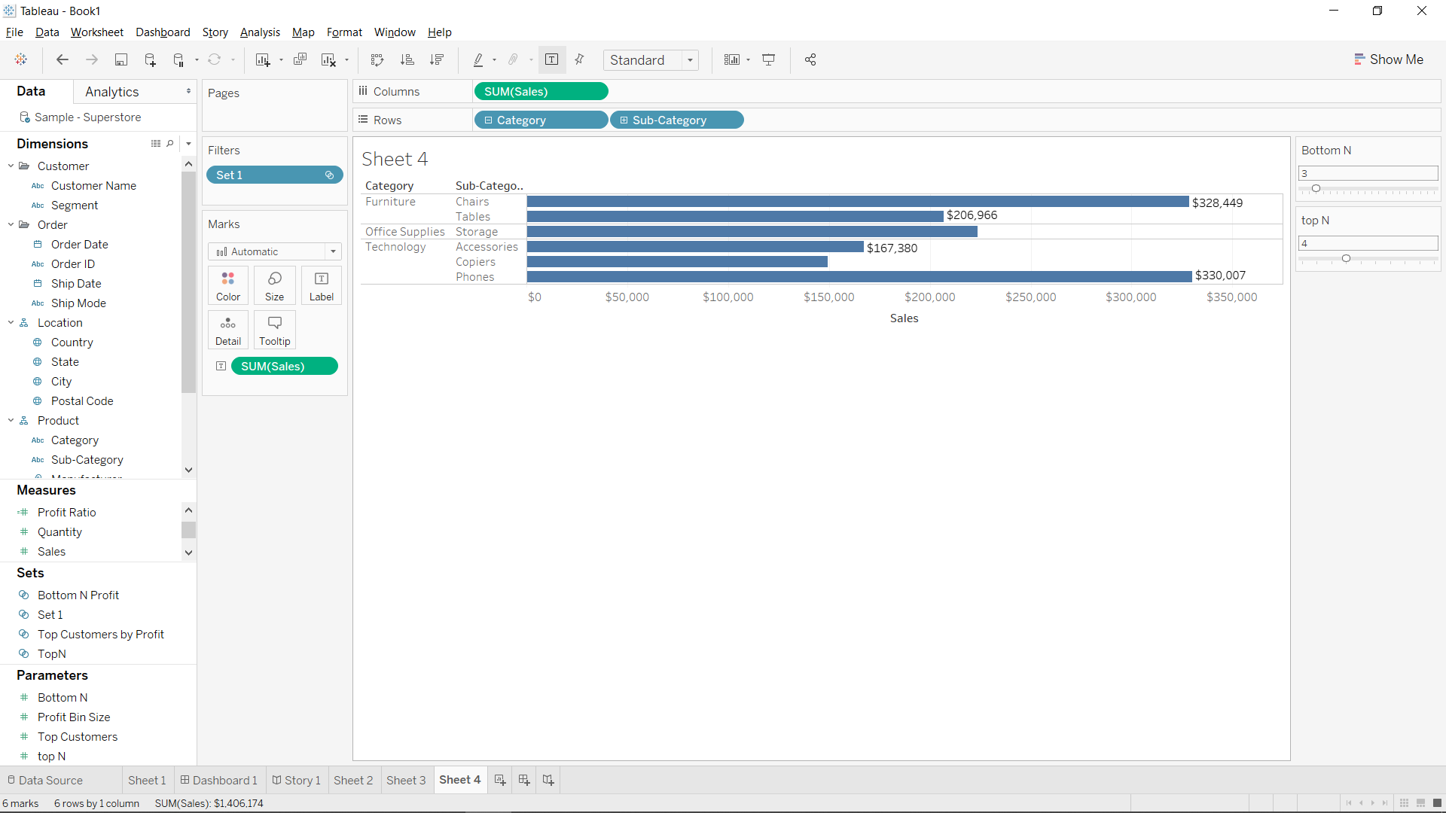

* **Interpretation:** By creating such parameters and sets this way, we can obtain top and bottom entries from the dataset.

1. Make an interactive treemap with the help of filters reflected on region-wise profit.

* Create a new worksheet and rename it as Tree Map.
* Drag and drop ‘category’, ‘sub category’ and ‘profit’ on labels in marks card.
* Drag and drop ‘profit’ on size in marks card.
* click on region and select show filter
* A legend will get generated in the right side of the worksheet from where you can select region wise you want to observe its sales.

**Interpretation:** This way, an interactive tree map can be obtained

Formatting:

* Create 1 new Dashboards
* On first dashboard, drag the sheet in first ans and put it on left, then the sheets of ans 2 on the right. on the left bottom, add the tree map
* Add the map on the right most corner
* This dashboard will also have legends to highlight the information as per your choice

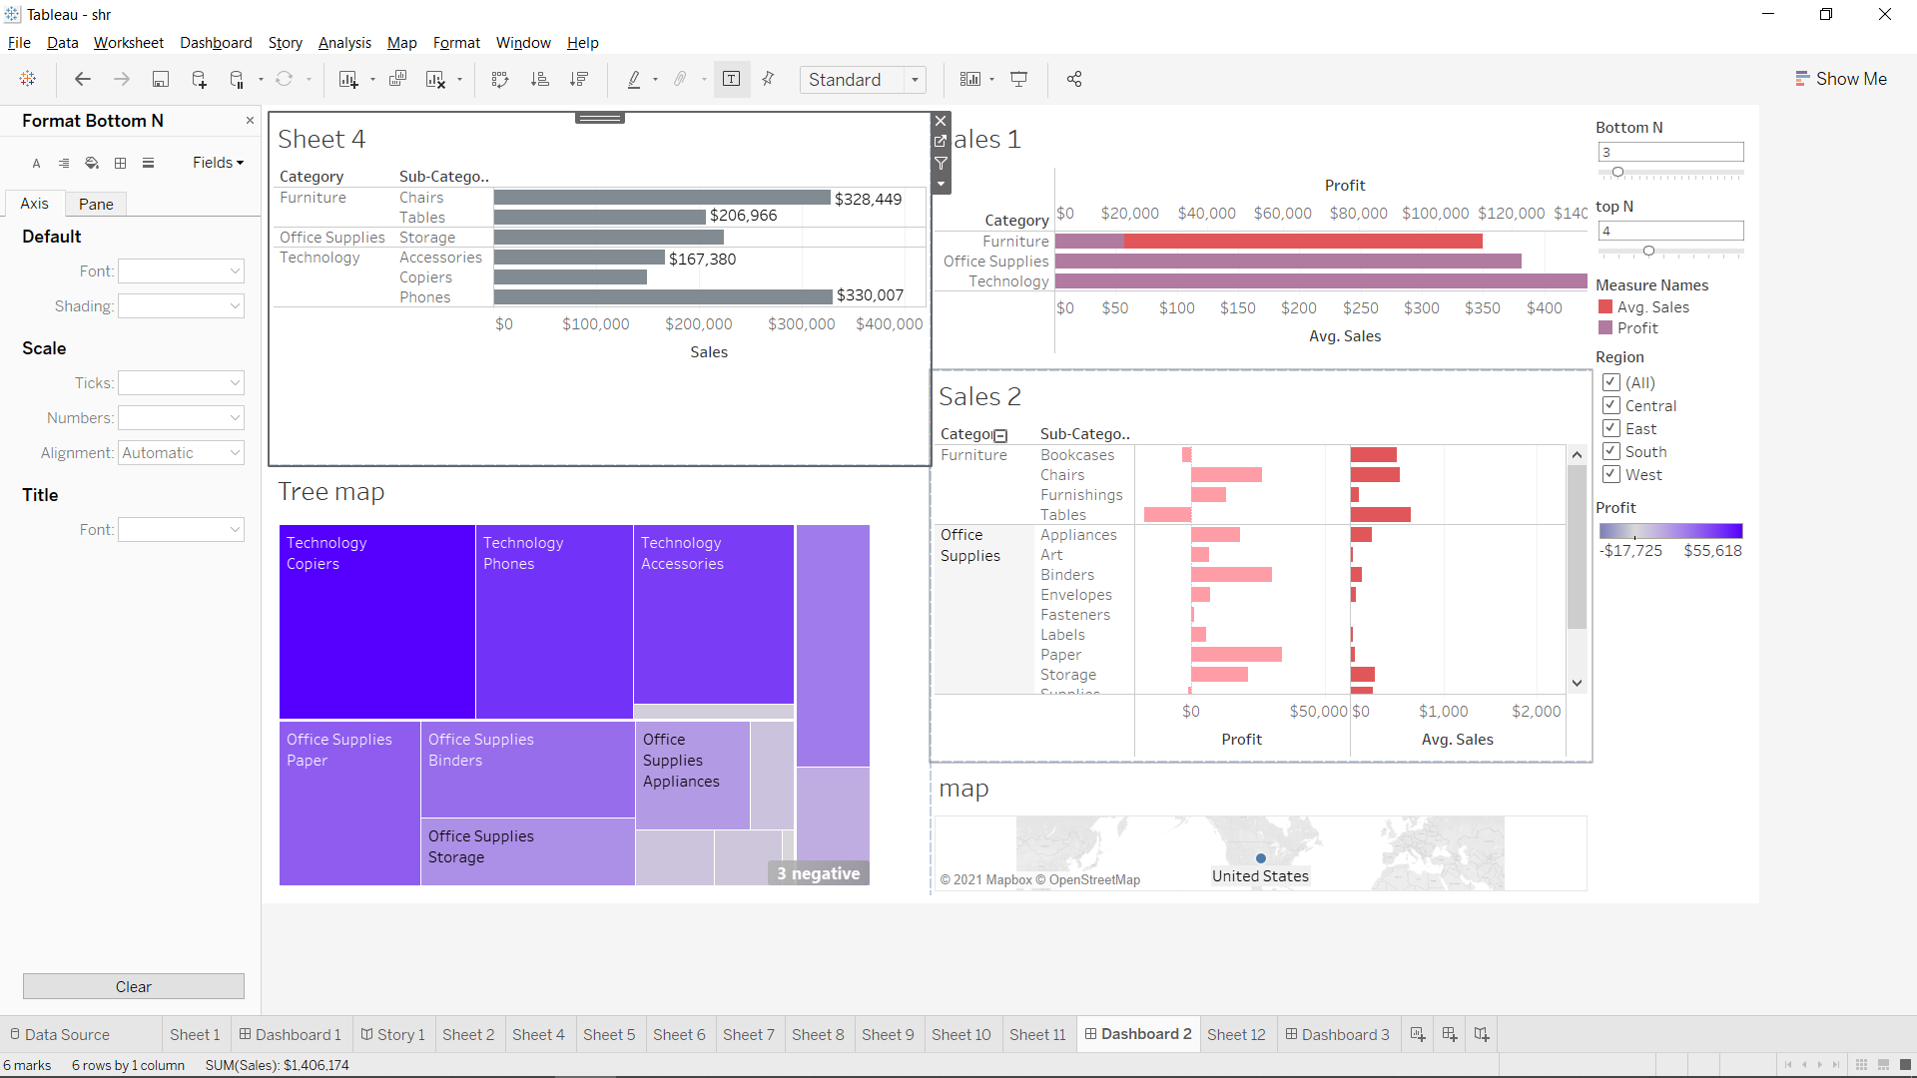

Creating a Story:

* Create a new story
* First add the map on which you had added the action
* Then, add a blank story point, and add the sheet the map action leads to.
* On the third sheet, add the above dashboard.

